**SUMMER INTERNSHIP REPORT**

**on**

**Study of High-Speed Imaging Techniques and**

**Design & Development of a Flash Detector Circuit**



**PROOF AND EXPERIMENTAL ESTABLISHMENT (PXE)**

**DEFENCE RESEARCH & DEVELOPMENT ORGANISATION (DRDO)**

**CHANDIPUR , BALASORE**

**756025**

**Under the Guidance of:**

**Mr. Prem Kumar Sahani (Scientist-D)**

**Submitted by:**

**Keshab Patro**

**B.Tech, 3rd year**

**Department of Electrical Engg.**

**National Institute of Technology, Rourkela**

**ACKNOWLEDGEMENT**

I would like to express my sincere gratitude to the **Defence Research and Development Organisation (DRDO)** for providing me with the invaluable opportunity to undertake my internship at one of the nation's foremost research institutions. This experience has been instrumental in enhancing my technical knowledge and research capabilities.

I am especially thankful to **Mr. Prem Kumar Sahani (Scientist-D)**, **Mrs. Sudeshna Mohapatra (Scientist-E)** and **Mr. SK Monirujjaman (TO-B)** for their expert guidance, continuous support, and valuable feedback throughout the course of my internship. Their mentorship greatly enriched my learning experience and helped me overcome technical challenges during the project work.

I would also like to extend my heartfelt appreciation to **Shri. S. K. Nayak, Director, PXE** and **Dr. Sankarsan Padhy (Scientist-F), Additional Director, R&S Wing and HRDC** for their leadership, support, and for fostering a research-driven environment that encouraged innovation and critical thinking.

I am grateful to the faculty and administration of **NIT Rourkela** for their support in facilitating this internship. I would also like to thank all the scientists, technical staff, and fellow interns at PXE, DRDO who assisted me and contributed to my learning through discussions and collaborative work.

Finally, I express my sincere thanks to my family and friends for their constant motivation and encouragement throughout this journey.

**ABSTRACT**

Defence innovation is a cornerstone for any nation striving to establish global leadership and ensure the security of its citizens. The design and testing of such strategic infrastructure require multidisciplinary expertise and a collaborative environment where innovative ideas can transition into practical solutions with minimal resistance.

During my Summer Internship at PXE, DRDO I gained invaluable exposure to the research ecosystem and operational dynamics of a premier defence research institution. My work spanned three key areas: the **determination of supply frequency in a flickered light** using high-speed imaging systems, the design and implementation of a **human reaction time measurement** setup using visual stimuli, and the development of a **camera triggering circuit** activated by **muzzle flash detection**.

These projects not only deepened my understanding of real-world engineering challenges but also enhanced my technical acumen in signal processing, circuit design, and human-machine interaction. The experience reinforced my commitment to contribute toward India’s vision of technological self-reliance.

# **TABLE OF CONTENTS**

1. **About DRDO ……………………………………………………………….05**

1. **About Proof and Experimental Establishment……………….…………..06**
2. **DRDO Products……………………………………………….……………08**
3. **About Camera and Its Uses in DRDO………………………….……....…15**
4. **Experiment 1a: Human Reaction Time Determination………….……...18**
5. **Experiment 1b: Frequency Estimation of Flickering Light ……...……..21**
6. **Flash Triggering Circuit (Design-1)……………………………….….…..24**
7. **Practical Implementation of Flash Triggering Circuit…………………..27**
8. **Fastest possible Flash Triggering Circuit…………………………………33**
9. **Conclusion …………………………………………………………...……35**
10. **References………………………………………………………..………..36**

**ABOUT DRDO**

The Defence Research and Development Organisation (DRDO) is India’s premier agency for research and development in defence technologies. Established in **1958** under the Ministry of Defence, DRDO was formed by merging the Defence Science Organisation with some existing technical development establishments. Headquartered in New Delhi, it has grown into a network of more than 50 laboratories working in diverse fields such as aeronautics, armaments, electronics, combat vehicles, engineering systems, instrumentation, missiles, advanced computing, and naval systems.

DRDO’s primary objective is to make India **self-reliant** in defense technologies and systems. It aims to design, develop, and produce cutting-edge weapons and equipment to support the Indian armed forces. Over the decades, it has played a critical role in strengthening India’s defense capabilities by delivering indigenous solutions like the Agni and Prithvi missile series, Tejas Light Combat Aircraft, Arjun Main Battle Tank, PINAKA multi-barrel rocket launcher, and Akash surface-to-air missile system.

The organization is divided into several clusters based on its areas of specialization, such as the Missile and Strategic Systems (MSS) cluster, Aeronautical Systems (Aero), and Naval Systems & Materials (NS&M). These clusters ensure focused research and efficient project execution. DRDO also collaborates extensively with academic institutions, public sector undertakings, and private industry to foster innovation and technology transfer.

One of the major contributions of DRDO is in the area of missile technology. Under the Integrated Guided Missile Development Programme (IGMDP), DRDO achieved remarkable progress in creating a family of strategic and tactical missiles. In addition, the organization is involved in developing technologies for cyber security, artificial intelligence, and electronic warfare.

In recent years, DRDO has also contributed significantly to civilian applications, especially during national emergencies. During the COVID-19 pandemic, DRDO developed ventilators, sanitization chambers, and PPE kits to support the healthcare sector.

In conclusion, DRDO stands as a pillar of India’s defense preparedness and technological advancement. Through its dedicated efforts and continuous innovation, DRDO not only enhances the country's strategic strength but also supports the vision of “Atmanirbhar Bharat” (Self-reliant India) in the field of defense and beyond.

**ABOUT PXE**

PXE, a premier DRDO lab, is located at Chandipur, Odisha, 15 km from Balasore on the coast of the Bay of Bengal.

**Vision:**

To transform into a world-class dynamic test and evaluation centre for armament stores.

**Mission:**

Test, evaluation, and proof of various armament stores.

* PXE is one of the oldest DRDO establishments, initially set up in 1895 by a government order.
* The first firing took place on 7 November 1895, with Captain R.T. Moore as the first Proof Officer.
* The lab was brought under the DRDO in 1958, leading to major modernization and global recognition.
* PXE specializes in testing guns, mortars, rockets, tank guns, naval weapons, and related ammunition.
* It also evaluates armour systems, including tank armour, ICVs, proximity fuzes, and more.
* Technologies developed include S-band and X-band radars and gun mounts for MBT Arjun.
* Chandipur’s crescent-shaped coast provides a natural and safe environment for projectile trials.

**Why Chandipur ?**

The Proof and Experimental Establishment (PXE) was strategically established at Chandipur, Balasore, Odisha, for a combination of unique geographical, logistical, and scientific advantages.

**1. Receding Sea Water – Over 3 km During Low Tide**

* **Chandipur beach is unique**: During low tide, the Bay of Bengal recedes by more than 3 km, exposing a wide stretch of hard-packed sand.
* This natural feature enables easy recovery of projectiles like artillery shells, bombs, rockets, and missile components without deploying divers or marine recovery units.
* **Why recovery matters**:  
  After any firing test, it is critical to retrieve the fired ammunition/projectile to:
  + Examine for **s**tructural deformities, cracks, or thermal damage
  + Perform failure analysis
  + Check ballistic integrity
* **Hard seabed**: The exposed seabed during low tide offers a flat and firm surface ideal for impact studies and projectile retrieval with minimal sinking or scattering.

**2. Crescent-Shaped Coastline (~5 km long)**

* The curved or crescent (half-moon) shaped coast provides a natural bay-like environment.
* This geography helps in:
  + Naturally bounding the flight path of test projectiles, preventing them from veering too far off due to crosswinds or misfires.
  + Reducing wave turbulence, making the waters calmer during low tide, which **a**ids in safe projectile recovery.
  + Serving as a semi-enclosed testing range, with minimal need for artificial barriers or containment areas.
* The ~5 km curvature makes tracking radars, cameras, and sensors easier to deploy in an arc for comprehensive telemetry.

**3. Uninhabited Coastal Belt**

* The area around PXE and Integrated Test Range (ITR) is sparsely populated, reducing risk to civilians and making it ideal for live-fire testing.

**4. Long Stretch of Open Land and Water**

* Provides a natural firing range for different artillery systems and allows for multiple trajectories (high-angle, flat, etc.).
* Facilitates **s**ea-based missile testing without needing a ship-based launch.

**5. Security and Surveillance**

* Coastal location allows easy airspace and maritime zone control.
* DRDO can temporarily block access to certain coastal and air zones during testing.

**6. Proximity to Other Defence Installations**

* Located near ITR (Integrated Test Range), Wheeler Island (now Abdul Kalam Island)—all major missile and rocket testing activities of India happen here.
* Logistical synergy for missile programs like Agni, Akash, BrahMos, etc.

**DRDO PRODUCTS**

**1. MBT Arjun:**

The Arjun Main Battle Tank (MBT) is India's indigenously developed third-generation main battle tank, designed by the Defence Research and Development Organisation (DRDO). It is one of the most advanced armored fighting vehicles in the Indian Army’s inventory.

**a. Overview of Arjun MBT**

* **Name:** Arjun MBT
* **Developer:** DRDO, India
* **Manufacturer:** Heavy Vehicles Factory (HVF), Avadi, Chennai
* **Entered Service:** 2004 (Arjun Mk I), followed by Mk II variant in the 2010s

**b. Key Specifications**

|  |  |  |
| --- | --- | --- |
| **Feature** | **Arjun Mk I** | **Arjun Mk II** |
| **Main Gun** | 120 mm rifled gun | Same, with better firepower |
| **Armor** | Kanchan composite armor | Improved Kanchan + ERA |
| **Engine** | 1,400 hp MTU diesel engine | Same |
| **Weight** | ~58.5 tons | ~68.6 tons |
| **Speed** | ~70 km/h (on road) | Slightly lower due to added weight |
| **Crew** | 4 (commander, gunner, loader, driver) | Same |
| **Fire Control** | Computerized with thermal imaging and laser rangefinder | Improved with automatic target tracking and night fighting capability |

**c. Special Features**

* **Indigenous Armor**: “**Kanchan**” composite armor is highly effective against APFSDS and HEAT rounds.
* **Advanced Fire Control System**: Enables firing on the move and under low visibility.
* **NBC Protection**: Nuclear, biological, and chemical protection systems for the crew.
* **Hydropneumatic Suspension**: Provides a smooth ride across rough terrain.
* **Auxiliary Power Unit**: Powers the electronics without the main engine.

**d. Comparison of the Arjun Mk II with other major MBTs**

|  |  |  |  |  |  |  |
| --- | --- | --- | --- | --- | --- | --- |
| **Feature** | **Arjun Mk II** | **T-90 Bhishma** | **M1A2 Abrams SEP V3** | **T-14 Armata** | **Type 99A** | **Leopard 2A7+** |
| **Origin** | India | India/Russia | USA | Russia | China | Germany |
| **Weight** | ~68.6 tons | ~46.5 tons | ~66.6 tons | ~55 tons | ~54 tons | ~66.5 tons |
| **Crew** | 4 | 3 | 4 | 3 | 3 | 4 |
| **Main Gun** | 120 mm rifled | 125 mm smoothbore | 120 mm smoothbore | 125mm smoothbore (auto) | 125 mm smoothbore | 120 mm smoothbore |
| **Armor** | Kanchan + ERA | Composite + ERA | Chobham + DU layers | Malachit ERA + capsule | Modular composite + ERA | Advanced composite + modular armor |
| **Engine** | 1,400 hp diesel | 1,000 hp diesel | 1,500 hp gas turbine | 1,500 hp diesel | 1,500 hp diesel | 1,500 hp diesel |
| **Power/Weight Ratio** | ~20.4 hp/t | ~21.5 hp/t | ~22.5 hp/t | ~27.2 hp/t | ~27.7 hp/t | ~22.5 hp/t |
| **Top Speed** | ~58 km/h | ~60 km/h | ~67 km/h | ~80 km/h | ~80 km/h | ~72 km/h |
| **Range** | ~500 km | ~550 km | ~425 km | ~500+ km | ~600 km | ~450 km |
| **Fire Control** | Advanced,with auto target tracking | Good (Russian tech) | Highly advanced, integrated sensors | AI-assisted system | Modern FCS | Superior digital FCS |
| **Night Vision/Thermal** | Yes | Yes | Yes | Yes | Yes | Yes |
| **Protection System** | Explosive Reactive + Kanchan + laser warning | Shtora + ERA | Trophy APS (in newer versions) | Afghanit APS | ERA + laser detection | Active/passive systems |

**2. Pinaka MBRL System:**

The Pinaka Rocket System is a multiple barrel rocket launcher (MBRL) developed by India’s DRDO. It is named after the bow of Lord Shiva and is a vital component of India’s artillery modernization.

**Key Features of the Pinaka Rocket System:**

**a. Purpose & Role**

* Designed to replace the older Russian **BM-21 Grad** systems.
* Provides **quick and high-volume saturation fire** against enemy targets at long ranges.
* Used for **area denial**, **suppression of enemy artillery**, and destruction of **concentrated troop formations**.

**b. Versions**

* **Pinaka Mk-I**:
  + Range: ~40 km
  + Warhead: High-explosive, incendiary, anti-tank, anti-personnel types
* **Pinaka Mk-II**:
  + Range: ~60–75 km
  + Improved guidance and accuracy (uses inertial navigation with GPS)
* **Pinaka Mk-III / Guided Extended Range (under development)**:
  + Range: ~90+ km
  + Enhanced precision and longer reach

**c. Launcher System**

* Mounted on **Tatra 8x8 trucks** for mobility.
* Each launcher has **12 tubes**, and a battery consists of 6 launchers.
* Fully automatic **reloading**, **laying**, and **firing** system.
* Fires a full salvo of 12 rockets in **44 seconds**.

**d. Guidance (for Mk-II and beyond)**

* Integrated navigation systems.
* Mid-course correction for improved accuracy.

**e. Indigenization & Production**

* Developed by DRDO; produced by Tata Power SED, Larsen & Toubro (L&T), and BEML.
* Export potential to friendly nations.

**f. Operational Use**

* Successfully used in the **Kargil War (1999)**.
* Deployed along **India's western borders** with Pakistan and **LAC** with China.

**g. Comparison of major Multiple Barrel Rocket Launcher (MBRL) systems including India's Pinaka Mk-II, USA’s HIMARS and M270 MLRS, and Russia’s BM-30 Smerch:**

|  |  |  |  |  |
| --- | --- | --- | --- | --- |
| **Feature** | **Pinaka**  **Mk-II** | **BM-30**  **Smerch** | **HIMARS** | **M270 MLRS** |
| **Origin** | India | Russia | USA | USA |
| **Range** | Up to 75 km | Up to 90–120 km | 70–300+ km | 70–300+ km |
| **Rockets/**  **Launcher** | 12 | 12 | 6 | 12 |
| **Guidance** | GPS + Inertial | Inertial/GLONASS | GPS + Inertial | GPS + Inertial |
| **Mobility** | Wheeled (Tatra) | Wheeled (MAZ) | Wheeled (FMTV) | Tracked (Bradley) |
| **Notable Feature** | Indigenous & rapid | Heavy warheads | Precision, mobility | Heavy tracked launcher |

**3.ATAGS (Advanced Towed Artillery Gun System):**

**a. Developed by:**

DRDO (specifically by **Armament Research & Development Establishment (ARDE)** in collaboration with **PXE**, and manufactured with partners like **Bharat Forge (Kalyani Group)** and **TATA Advanced Systems**).

**b. Overview**

ATAGS is an **indigenous 155 mm, 52-calibre towed artillery gun system** developed under India's "Make in India" initiative. It aims to modernize the Indian Army’s artillery regiments with a powerful, long-range, and fully automated gun.

**c. Key Features and Capabilities**

|  |  |
| --- | --- |
| **Feature** | **Details** |
| **Caliber** | 155 mm |
| **Barrel Length** | 52 Calibre (i.e., 52 x bore diameter) |
| **Range** | Over **48 km** with extended range projectiles (record achieved: **48.074 km**) |
| **Rate of Fire** | 5 rounds per minute (sustained), burst mode: 3 rounds in 30 seconds |
| **Ammunition Compatibility** | NATO standard 155 mm ammunition |
| **Weight** | ~18 tons |
| **Automation** | Fully automated loading and laying system |
| **Crew Required** | 6–8 personnel |
| **Mobility** | Towed by high-mobility vehicle (8x8 truck) |
| **Fire Control System** | Electro-mechanical, with advanced ballistic computer & GPS support |
| **Recoil System** | Advanced retractable hydro-pneumatic recoil |

**d. Notable Achievements**

* **World Record**: Longest range achieved in its class (over 48 km with HE-BB ammunition).
* Successfully tested in **Sikkim and Pokhran** under extreme temperatures and terrain.
* Developed by a **consortium approach**: DRDO (ARDE, PXE), Bharat Forge, Tata Advanced Systems.

**e. Advantages Over Older Systems**

* Greater range and accuracy than **Bofors FH-77B**.
* Fully automated features reduce crew fatigue and increase speed.
* Modular design allows easy maintenance and upgrades.
* Contributes to **strategic autonomy** in defense production.

**f. Comparison with Other Artillery Guns**

|  |  |  |  |  |  |
| --- | --- | --- | --- | --- | --- |
| **System** | **Country** | **Caliber** | **Barrel Length** | **Max Range** | **Remarks** |
| **ATAGS** | India | 155 mm | 52 cal | **~48 km** | Indigenous, advanced FCS |
| **M777 (Ultra Light)** | USA/UK/India | 155 mm | 39 cal | ~30 km | Lightweight, air-portable |
| **Caesar** | France | 155 mm | 52 cal | ~42 km | Wheeled self-propelled |
| **K9 Vajra-T** | South Korea/India | 155 mm | 52 cal | ~40 km | Tracked self-propelled |

**g. ATAGS vs Bofors FH-77B Comparison Table**

**Bofors FH-77B**: the 155 mm howitzer that India imported from Sweden in the 1980s.

|  |  |  |
| --- | --- | --- |
| **Feature** | **ATAGS** (India) | **Bofors FH-77B** (Sweden) |
| **Caliber** | 155 mm | 155 mm |
| **Barrel Length** | 52 Calibres | 39 Calibres |
| **Max Range** | ~48 km (with Extended Range Base Bleed) | ~24–30 km (with standard ERFB-BB rounds) |
| **Rate of Fire** | 5 rounds/min (sustained); 3-round burst in 30 sec | 3 rounds in 15 seconds burst; sustained 2 rds/min |
| **Automation** | Fully automated loading and laying | Semi-automatic loading |
| **Weight** | ~18 tons | ~11.5 tons |
| **Crew Required** | 6–8 personnel | 6–8 personnel |
| **Recoil System** | Advanced Electro-Hydraulic Recoil System | Hydro-pneumatic recoil |
| **Mobility** | Towed by 8x8 high mobility truck (TATA or Bharat Forge) | Towed by trucks (originally by Scania trucks) |
| **Fire Control System** | Digital, Electro-Mechanical with GPS and INS guidance | Manual sights and analog FCS |
| **Ammunition Compatibility** | NATO 155 mm standard rounds | NATO 155 mm standard rounds |
| **Indigenous Content** | ~80–90% (designed and built in India) | Completely imported from Sweden |
| **Operational Since** | Under induction since 2023 (in trials earlier) | Inducted in Indian Army in 1986–87 |

**Conclusion**

While **Bofors FH-77B** served India extremely well (especially during the **Kargil War**), the **ATAGS** is a significant **technological leap forward**, providing:

* Longer range
* Greater firepower
* Better accuracy
* Indigenous capability

ATAGS is not just a replacement, but a **next-generation artillery system** suited for modern battlefield requirements.

**ABOUT CAMERA**

A camera is a device that captures images or videos by recording light through a lens. It typically consists of a sensor (like a digital sensor or film) that captures the light, and a lens that focuses the image. Cameras can be used for a wide range of purposes, from photography to video recording, and come in various forms, such as smartphones, DSLRs, and mirrorless models. The quality of the captured image depends on factors like resolution, lens quality, and sensor size.

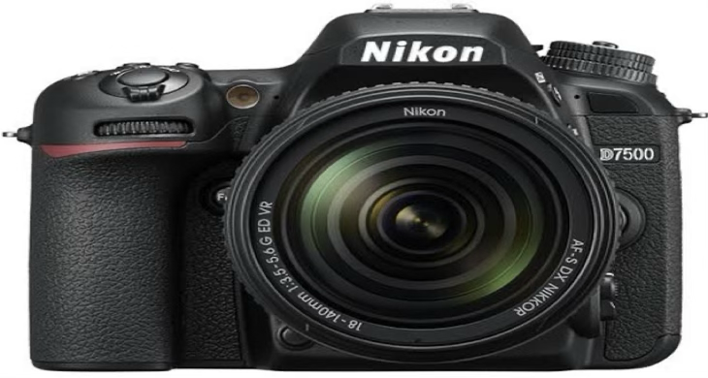Fig: DSLR Camera

**ABOUT SENSORS**

A sensor camera uses image sensors to capture visual data. It detects light through lenses, converts it into electronic signals, and creates images or videos for monitoring or analysis.They are two type of image sensors used in digital cameras imaging devices .

1. Complementary Metal Oxide Semiconductor (CMOS)
2. Charged Couple Device (CCD)

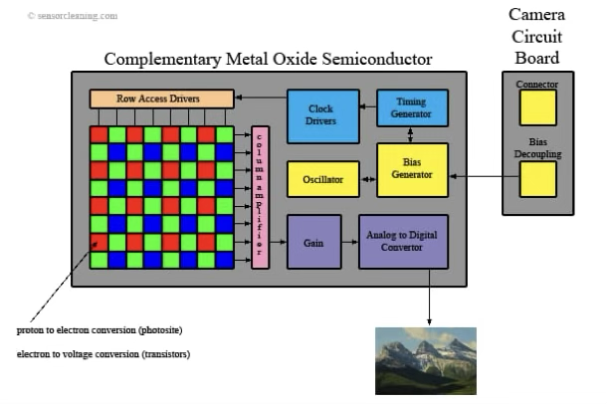**CMOS-** A CMOS sensor camera uses a Complementary Metal-Oxide-Semiconductor sensor to capture images. It's energy-efficient, fast, and commonly found in smartphones, webcams, and digital cameras. CMOS sensors convert light into electrical signals, enabling digital image processing.

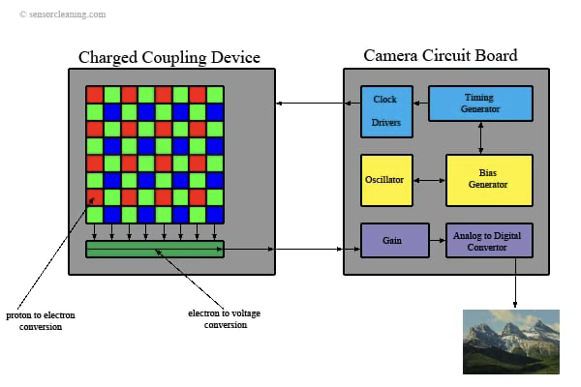**CCD -** A CCD sensor camera uses a Charge-Coupled Device to capture images. Here's a simple explanation. CCD sensor camera. Converts light into electrical signals using a special chip. Known for high image quality, low noise, and accurate color reproduction. Commonly used in professional photography, astronomy, and medical imaging. Generally consumes more power and is more expensive than CMOS cameras.

**CAMERA COMPONENTS**

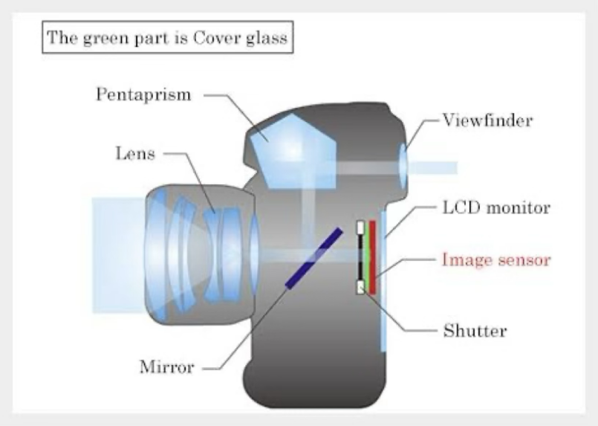The main components of a camera :

**1)Lens:** Focuses light onto the sensor.

**2)Image Sensor:** Captures the image (e.g., CMOS, CCD).

**3)Shutter:** Controls how long light hits the sensor.

**4)Aperture:** Regulates the amount of light entering..

**5)Viewfinder/Screen:** Helps compose the shot.

**6)Processor:** Processes image data.

**7)Storage:** Saves photos (e.g., SD card).

**8)Battery:** Powers the camera.

**9)Body:** Holds all components together.

**10)Pentaprism:** Used in DSLR cameras; it reflects light from the lens to the optical viewfinder, allowing you to see exactly what the lens sees in real-time (optical view).

**11) LCD Mirror** - Found on digital cameras displays digital preview from the camera sensor ,allowing live view,playback, and menu access.

**CAMERA USES IN DRDO**

**DSLR:** The Nikon D5 is a professional-grade DSLR camera known for its speed,

durability, and low-light performance.

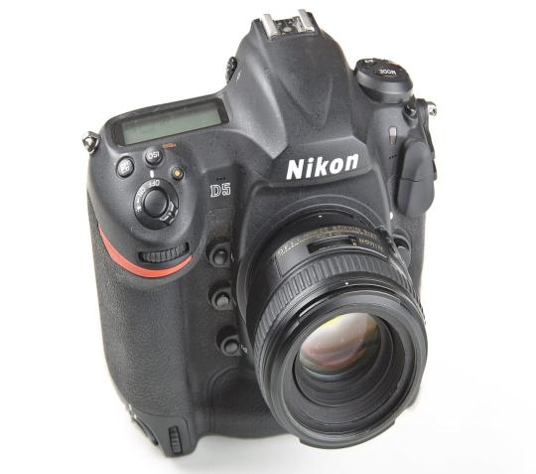

**Key features include:**

1. 20.8 MP full-frame sensor EXPEED 5

image processor

1. 12 fps continuous shooting.
2. 4K UHD video recording.
3. 153-point autofocus system.
4. Dual XQD or CF card slots.

**PHOTRON FASTCAM SA5:** The Photron FASTCAM SA5 is a high-speed camera offering:

* **Frame Rate:**
  + Up to **7,500 fps** at **full resolution** (1,024 × 1,024 pixels)
  + Up to **775,000 fps** at **reduced resolution** (128 × 24 pixels)
* **Sensor Type:**
  + **12-bit CMOS sensor** (monochrome)
  + **Pixel size:** 20 µm
* **Exposure Time:**
  + As low as **369 nanoseconds**
  + Typical **minimum exposure time: 1 microsecond**
* **Control Interface:**
  + **Standalone operation** using **5-inch LCD keypad**
  + **Software control** via **Photron FASTCAM Viewer (PFV)**
* **Applications:**
  + **Ballistics** (e.g., visualizing muzzle flash and projectile motion)
  + **Particle Image Velocimetry (PIV)**
  + **Combustion** and **explosion** analysis
  + **Aerospace**

**Experiment 01:**

**(a) Human Reaction Time: To measure the reaction time of an individual**

**1. Introduction**

Human reaction time is a critical measure of how quickly an individual can respond to a stimulus. In defence applications, rapid decision-making and reflexes are essential for operators handling live weapon systems, surveillance feeds, or battlefield control systems.

This experiment aimed to evaluate and compare reaction times using high-speed imaging techniques, both for:

* A single individual, using a mechanical ruler drop test
* Two individuals, using a mechanical ruler drop test

Single individual:

**2. Objective**

* To measure the reaction time of a single individual in response to a specific stimulus.
* To assess sensory-motor coordination, cognitive processing speed, and responsiveness.

**3. Methodology**

• A standard ruler was held vertically and dropped from a fixed height.

• The entire action was recorded using a high-speed camera operating at **1000 frames per second (fps)**.

• The reaction time was calculated by:

* Identifying the frame at which the ruler was released (**stimulus frame**).
* Identifying the frame at which the individual caught the ruler (**response frame**).
* Applying the formula:



**4.** **Data Table**

**5. Result:**

**Average Human Reaction Time (Single Individual): 103.8 milliseconds**

Two individuals:

**2. Objective**

* To compare the reaction times of two individuals in response to the same stimulus.
* To analyse differences in:
* Cognitive processing speed
* Motor coordination
* Attention and decision-making ability

**3. Methodology**

• A standard ruler was held vertically and dropped from a fixed height.

• The entire action was recorded using a high-speed camera operating at **1000 frames per second (fps)**.

• The reaction time was calculated by:

* Identifying the frame at which the ruler was released (**stimulus frame**).
* Identifying the frame at which the individual caught the ruler (**response frame**).
* Applying the formula:



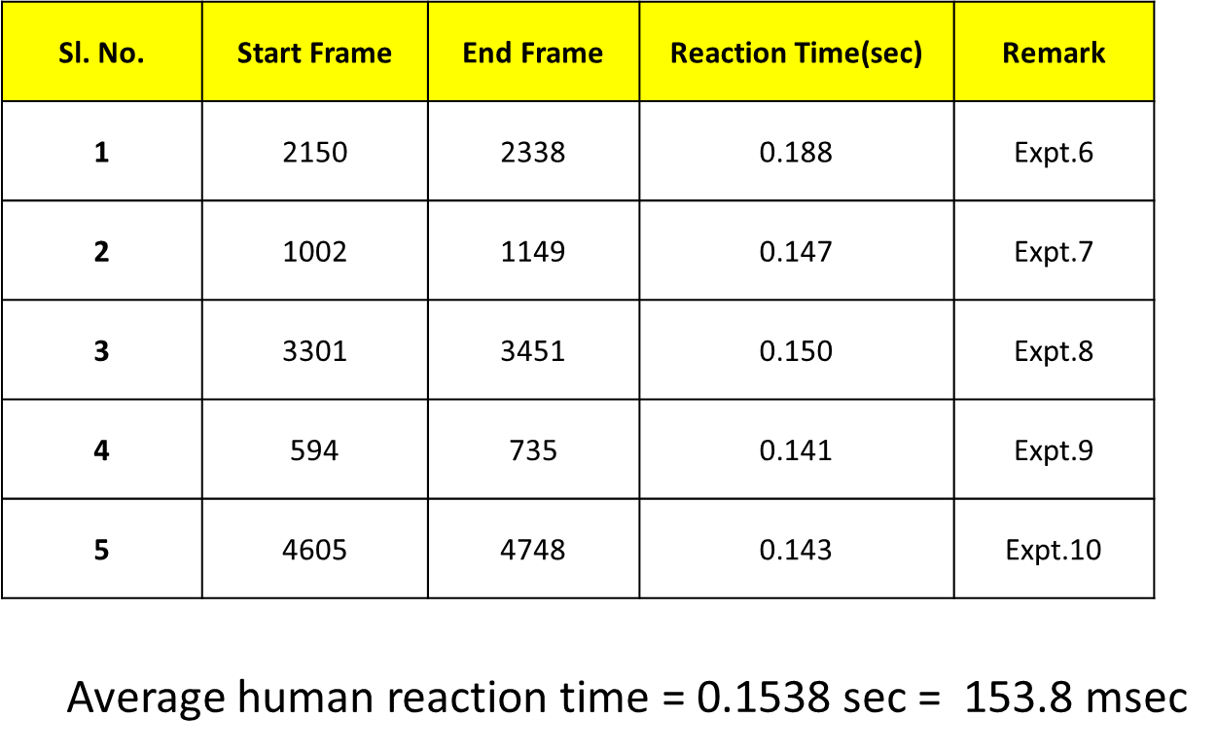**4.** **Data Table**

**5. Result:**

**Average Human Reaction Time (Single Individual): 153.8 milliseconds**

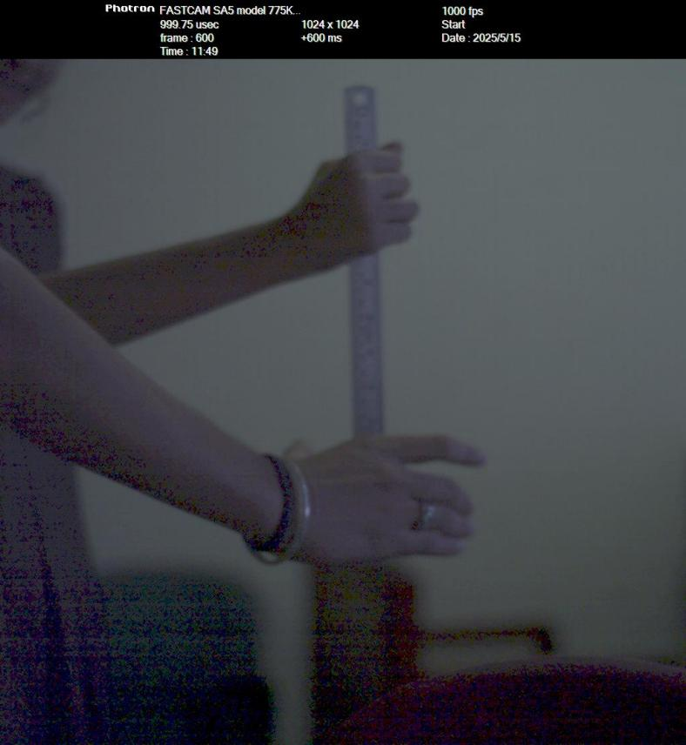Two individuals test showed **longer reaction times**, as expected, due to:

* + Delay in recognizing physical motion
  + Cognitive processing of another person's action
  + Physical anticipation differences

**6. Observations & Insights**

* Reaction time is affected by **stimulus type**, **environment**, and **human readiness**.
* The use of **high-speed imaging** provided accurate detection of stimulus-response gaps without relying on timers or stopwatches.
* **Variability across trials** was observed depending on:
  + Distraction levels
  + Familiarity with the stimulus
  + Motor readiness

**7. Applications in Defense**

|  |  |  |  |
| --- | --- | --- | --- |
| **Area** |  |  | **Impact of Reaction Time** |
| **Surveillance Operators** |  |  | Faster identification of targets or alerts |
| **Drone/UAV Pilots** |  |  | Quick response to control deviations or threats |
| **Live Combat Controllers** |  |  | Time-critical engagement decisions |
| **Simulation Training Systems** |  |  | Useful in assessing personnel readiness and fatigue levels |

### **8. Conclusion**

* The experiment successfully demonstrated **accurate measurement of human reaction time** using high-speed cameras.
* Results confirm that even **milliseconds matter** in operational decision-making environments.
* Such studies can guide:

Selection and training of defense personnel

Design of **human-in-the-loop systems**

Evaluation of **reaction-critical mission interfaces**

**Experiment: 01 (b) Frequency Estimation of Flickering Light**

### **1. Introduction**

In real-time vision-based systems used in defense and automation, **lighting stability** is critical. Most environments, including test ranges, surveillance stations, and labs, rely on **LED illumination**. However, many LEDs powered by **AC mains** exhibit **flickering** — rapid fluctuations in brightness — due to current modulation at the power line frequency (50 Hz in India). Though often imperceptible to the naked eye, this flickering can interfere with:

* Image processing accuracy
* Optical sensing systems
* High-speed camera operations
* Personnel visual comfort and cognitive fatigue

The objective of this experiment is to use **high-speed imaging** to analyze the nature and frequency of LED flickering and assess its impact on vision-dependent systems.

### **2. Objective**

To detect and analyze the **flickering characteristics of an AC-powered white LED** using high-speed video and pixel-wise RGB data. The study aims to determine:

* Whether the flicker is periodic and synchronized across color channels
* If it matches power line frequency (50 Hz)
* The implications for vision systems in defense applications

### **3. Experimental Setup**

|  |  |
| --- | --- |
| **Parameter** | **Details** |
| **Camera** | High-speed camera (Photron FASTCAM SA5 or equivalent) |
| **Frame Rate** | 1000 fps (sufficient to capture multiple samples per flicker cycle) |
| **Lighting Source** | White LED (AC powered, standard 50 Hz frequency) |
| **Captured Data** | RGB pixel values across 16 frames |
| **Software Tools** | MATLAB for luminance and brightness calculation and visualization |
| **Region of Interest** | Fixed pixel area under consistent illumination |

### **4. Methodology**

1. **High-Speed Video Recording**  
   A white LED was recorded at 1000 fps for at least 16 frames using a high-speed camera setup.
2. **Data Extraction**  
   RGB pixel values were extracted for a static region of the image across all frames.
3. **Luminance and Brightness Calculation**

* **Perceived Luminance** was calculated using the industry-standard weighted formula:

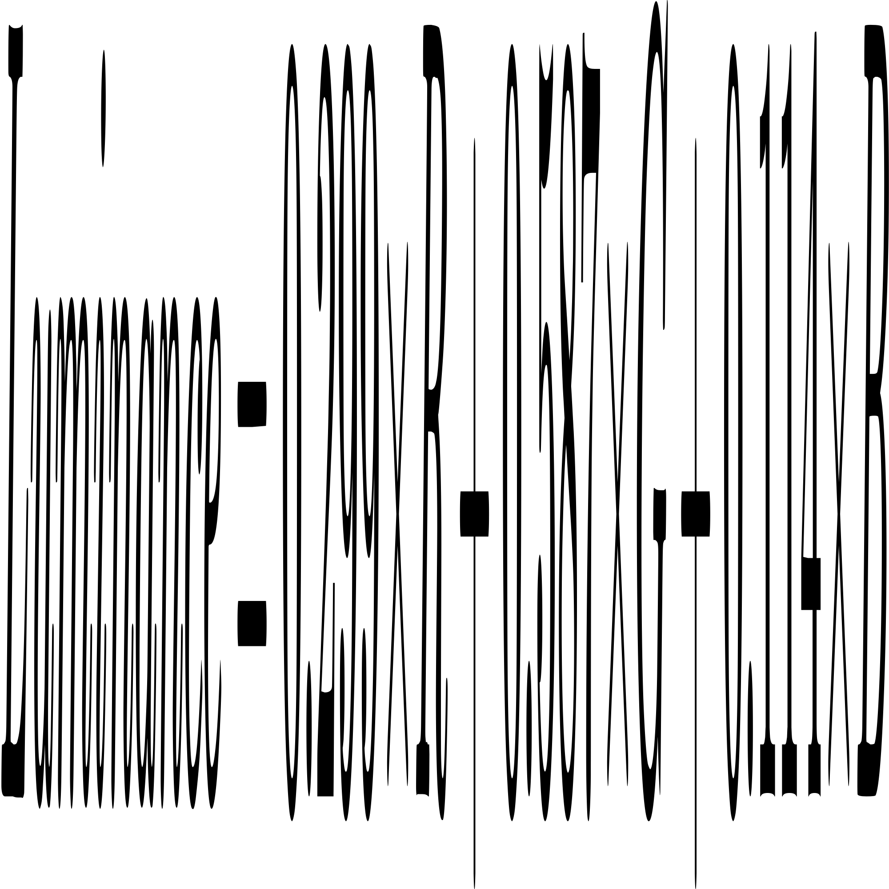

* **Average Brightness** was computed as the simple mean of R, G, and B values.

1. **Waveform Plotting**  
   Intensity curves were plotted to visualize oscillations across time (frames).

|  |  |  |  |  |  |
| --- | --- | --- | --- | --- | --- |
| Frame | R | G | B | Perceived Luminance | Avg Brightness |
| 1 | 90 | 123 | 128 | 116.3452 | 112.53 |
| 2 | 96 | 132 | 138 | 124.7796 | 120.78 |
| 3 | 94 | 128 | 133 | 121.1326 | 117.15 |
| 4 | 81 | 111 | 117 | 105.0552 | 101.97 |
| 5 | 62 | 87 | 91 | 81.9738 | 79.2 |
| 6 | 47 | 65 | 66 | 61.2454 | 58.74 |
| 7 | 38 | 53 | 54 | 49.8832 | 47.85 |
| 8 | 43 | 60 | 63 | 56.6024 | 54.78 |
| 9 | 59 | 81 | 86 | 76.6838 | 74.58 |
| 10 | 76 | 102 | 108 | 96.9056 | 94.38 |
| 11 | 90 | 123 | 127 | 116.273 | 112.2 |
| 12 | 97 | 132 | 135 | 124.7756 | 120.12 |
| 13 | 94 | 130 | 134 | 122.6352 | 118.14 |
| 14 | 81 | 111 | 118 | 105.1274 | 102.3 |
| 15 | 64 | 89 | 90 | 83.7572 | 80.19 |
| 16 | 47 | 65 | 67 | 61.3176 | 59.07 |

### **5. Observations**

#### **Periodic Behavior**

* All three channels (R, G, B) exhibited **synchronized oscillations** over time.
* **Brightness dips** were consistently noted around **frames 6–8**.
* **Peak intensities** occurred near **frames 2–3** and **11–12**.
* This waveform confirms **cyclical flickering** typical of 50 Hz AC.

#### **Waveform Shape**

* The brightness curve resembled a **sinusoidal** or smoothed square wave.
* Confirms that flicker is due to **power supply modulation**, not random variation.

#### **Visual Graph (from presentation)**

* X-axis: Frame number (16 total)
* Y-axis: Pixel intensity for R, G, and B
* The graph clearly shows rise and fall in a **coordinated pattern**, proving system-wide luminance flicker

### **6. Results**

|  |  |
| --- | --- |
| **Metric** | **Observation** |
| **Flicker Frequency** | Matches 50 Hz AC mains cycle (based on 20 ms period at 1000 fps) |
| **Color Channel Sync** | Flickering affects R, G, B simultaneously |
| **Waveform Type** | Periodic, smooth sinusoidal pattern |
| **Human Visibility** | Not easily visible at full brightness, but evident under analysis |
| **Image Integrity Risk** | High — may impact frame-based processing systems |

### **7. Conclusion**

The LED source exhibits a **clearly periodic flickering pattern** caused by AC power line modulation. The flicker:

* Is **synchronized across RGB channels**
* **Aligns with the 50 Hz power frequency**
* Can **impact optical systems** used in defense, such as:
* Flash-based triggering
* Ballistics imaging
* Target acquisition
* Surveillance tracking

**Experiment 02: Flash Detecting Circuit**

**Design-1: Simulation and Design of a Muzzle flash detection based triggering circuit using LDR**

**Objective:**

We aim to develop a trigger circuit that initiates camera recording by delivering a 5V pulse upon detecting a muzzle flash in the visible spectrum. This system enables precise capture of projectile motion using high-speed cameras, minimizing storage waste by starting the recording only after the firearm is discharged. The circuit must offer low response time and be capable of handling significant loads, with current requirements as high as 0.45A, to ensure smooth and reliable operation.

**Components:**

1. **LDR (Photoresistor)**

Type: Activated by visible spectrum

Response Time: 2-50 ms (Slower than a phototransistor)

1. **NPN Transistor (BC547)**

Configuration: Common Emitter Configuration (Highest Input Impedance and Lowest Output Impedance)

Frequency Reliability: upto 300MHz

1. **Operational Amplifier (LM741)**

Working as: Comparator

Slew rate: 0.7V/uS i.e. for +5V, Response time = 7.2 uS

1. **Micro-controller as D-Latch**

Polling loop running at 1ms interval

**Circuit Schematic:**

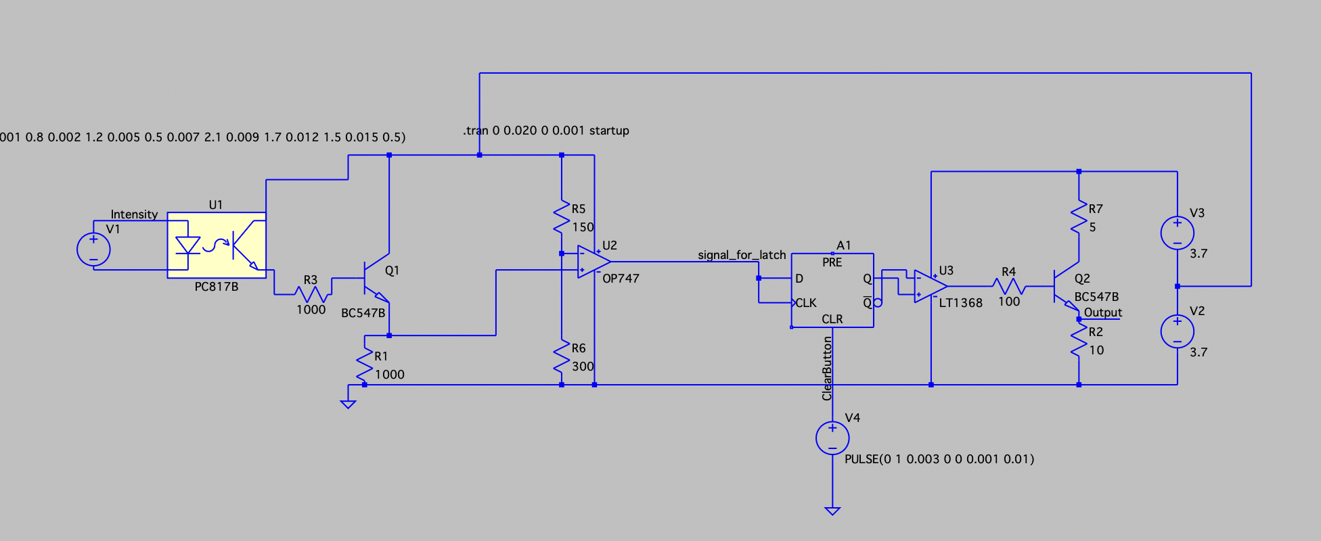

**Stages in the Circuit:**

### **Stage 1: Light Intensity Detection and Comparator**

The LDR senses light intensity changes and changes the resistance values, essentially turning on transistor Q1. This results in a varying voltage at the collector of Q1, which is fed into an op-amp (OP747) configured as a comparator. The comparator compares this voltage against a fixed reference set by a resistor divider (R5 and R6) and outputs a digital high or low signal based on whether the light intensity crosses a threshold.

### **Stage 2: Memory Element using D Flip-Flop**

The output of the comparator acts as a trigger input (D) for a D flip-flop (A1), which is used to latch the state, ensuring that transient or fluctuating signals from varying light don’t cause repeated or unstable triggering. The flip-flop holds the output until a clear/reset signal (from V4 pulse source simulating a clear button) is received.

### **Stage 3: Current Amplification**

The latched output is fed into another op-amp (LT1368) acting as a buffer or driver to control a power transistor (Q2, BC547B), which switches the output load. The resistor R7 (5Ω) in series with the load enables current handling up to 0.45 A, powered by two 3.7V sources (V2 and V3), effectively driving a high load.

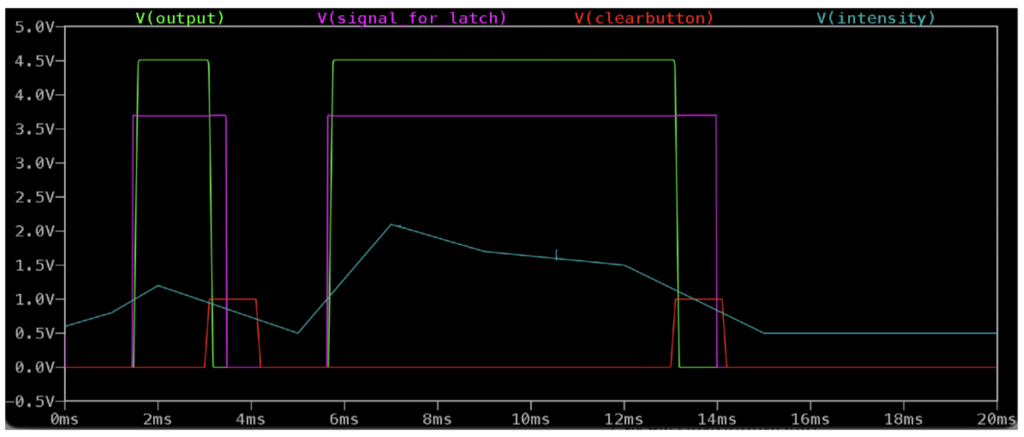

**Simulation:**

Waveform showing the response of the circuitry (in green) to the light intensity variation (in blue) which is only interrupted by the clear command.

**Hardware design:**

The circuit was connected on a breadboard while ensuring the power ratings and finally a +5V edge was obtained with minimal variation (10%) for loads as high as 0.45A.

**Hardware connection:**

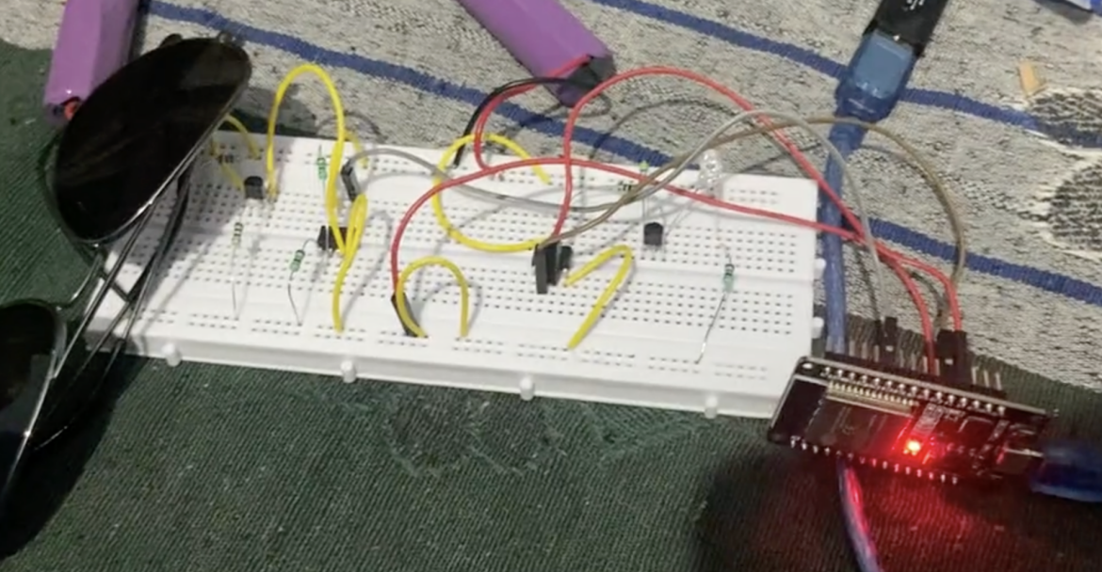

**Possible Improvements:**

1. Sunlight filtering is not integrated with the LDR and temporarily implemented here using a sunglass.
2. IR based triggering methods could be included with this setup as those wavelengths are also emitted in muzzle flash and their fast response could improve the response time of the circuit.

**Conclusion:**

The circuit works well for detecting a muzzle flash and triggering a 5V pulse to start camera recording. It reacts quickly, handles high current (up to 0.45A), and avoids false triggers using a latch. Both simulation and real tests showed stable performance. Though sunlight filtering was basic, it still reduced unwanted triggers. In the future, using infrared detection and better filters can improve it further. This setup helps save storage by only recording after a shot is fired.

**Design Optimization and Delay Reduction in Flash Triggering Circuit**

**Identified Limitations in the Initial Design**

The original implementation of the Flash Detection Circuit, hereafter referred to as *Design-1*, exhibited significant latency, primarily due to the choice of slow analog components. The theoretical delay estimation of the original circuit is as follows:

|  |  |
| --- | --- |
| **Component Chain** | **Delay Contribution** |
| LDR | 100 ms |
| BC547 (BJT) | 100 ns |
| UA741 Op-Amp (×2 stages) | 20 µs + 20 µs = 40 µs |
| D Flip-Flop (74LS74) | 30 ns |
| BC547 (final stage) | 100 ns |
| **Total** | **100.04023 ms** |

This high delay, dominated by the LDR response time (~100 ms), rendered the system unsuitable for high-speed flash detection, especially in defense-related applications such as projectile or explosion studies.

**Recommendations and Targets**

Based on inputs from the Director, PXE (Proof & Experimental Establishment), the following recommendations were made to enhance circuit performance:

* **Minimize overall circuit delay to under 1 microsecond.**
* **Explore sub-microsecond and nanosecond-range optimizations wherever feasible.**

**Practical Implementation and Circuit Modifications**

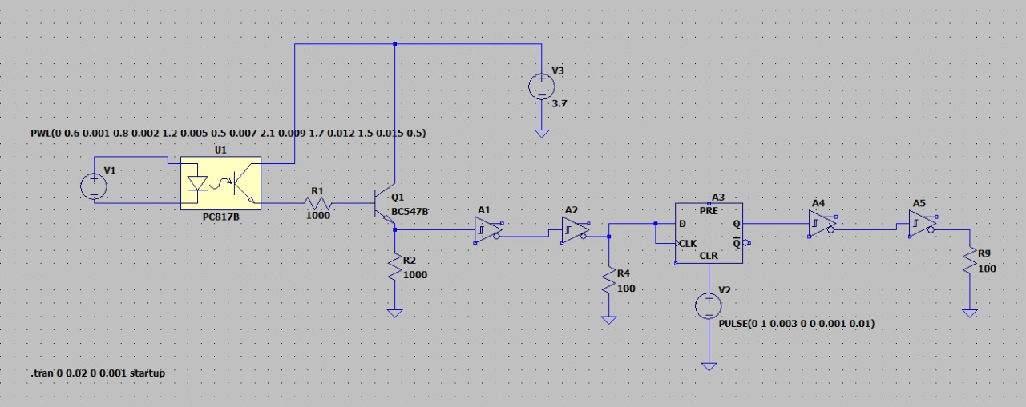

The following changes were implemented:

* **Replaced the UA741 operational amplifiers and RTL-based amplification stages** with TTL-compatible digital components.
* **Adopted a logic-based architecture using the 74LS14 (Hex Schmitt Trigger Inverter)** for signal conditioning.
* **Replaced the LDR with a fast PIN photodiode (BPW34)** for faster optical detection.

**Theoretical Delay Analysis of Revised Design**

A stage-wise analysis of the new architecture's theoretical delays is summarized below:

**1. Photodiode (BPW34) Response**

* Rise Time (10% to 90%): 100 ns (as per datasheet)
* Junction Capacitance: ~40 pF (at 5V reverse bias)
* With 10 kΩ load:  
  RC Time Constant, τ = R × C = 10kΩ × 40pF = **400 ns**  
  Settling Time (≈ 2.2 × τ): **≈ 880 ns**

**2. BJT Amplifier Stage (BC547)**

* Transition Frequency (fT): ~100 MHz
* Ideal Switching Delay: ≈ 1.6 ns
* Accounting for parasitic capacitance (~15 pF) on a typical PCB with 1kΩ load:  
  RC Delay = 1kΩ × 15pF = **15 ns**  
  Total Estimated Delay: **≈ 20 ns**

**3. Schmitt Trigger Stage (74HC04)**

* Propagation Delay (per inverter, Vcc = 5V): **15 ns**
* Two stages in series for waveform conditioning:  
  Total Delay: **15 ns × 2 = 30 ns**

**4. D Flip-Flop (74HC74)**

* Clock-to-Q Delay: **25 ns**
* Setup Time: **20 ns**  
  (Input must remain stable before the clock edge)
* Total Delay Contribution: **≈ 45 ns**

**5. Output Inverter Stage (74HC04)**

* Two additional inverters used for clean digital output:  
  Delay: **15 ns × 2 = 30 ns**

**Cumulative Delay Summary**

|  |  |
| --- | --- |
| **Stage** | **Delay (ns)** |
| Photodiode (BPW34) | 880 |
| BC547 Amplifier | 20 |
| First Inverter Pair | 30 |
| 74HC74 D Flip-Flop | 45 |
| Output Inverter Chain | 30 |
| **Total Theoretical Delay** | **1,005 ns (~1 µs)** |

**Conclusion**

Through careful redesign and component substitution, the total circuit delay has been reduced from approximately **100 ms** to **1 µs**, achieving a speedup of **five orders of magnitude**. The design now satisfies the requirement of sub-microsecond detection and serves as a scalable, real-time flash triggering system suitable for high-speed imaging and projectile-based experiments.

**Hardware connection:**

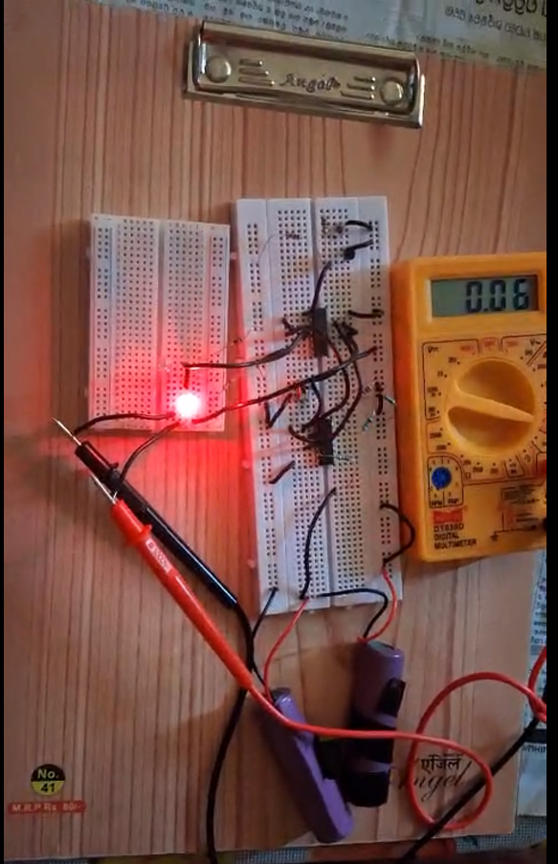

**Practical delay of this circuit measured using oscilloscope:**

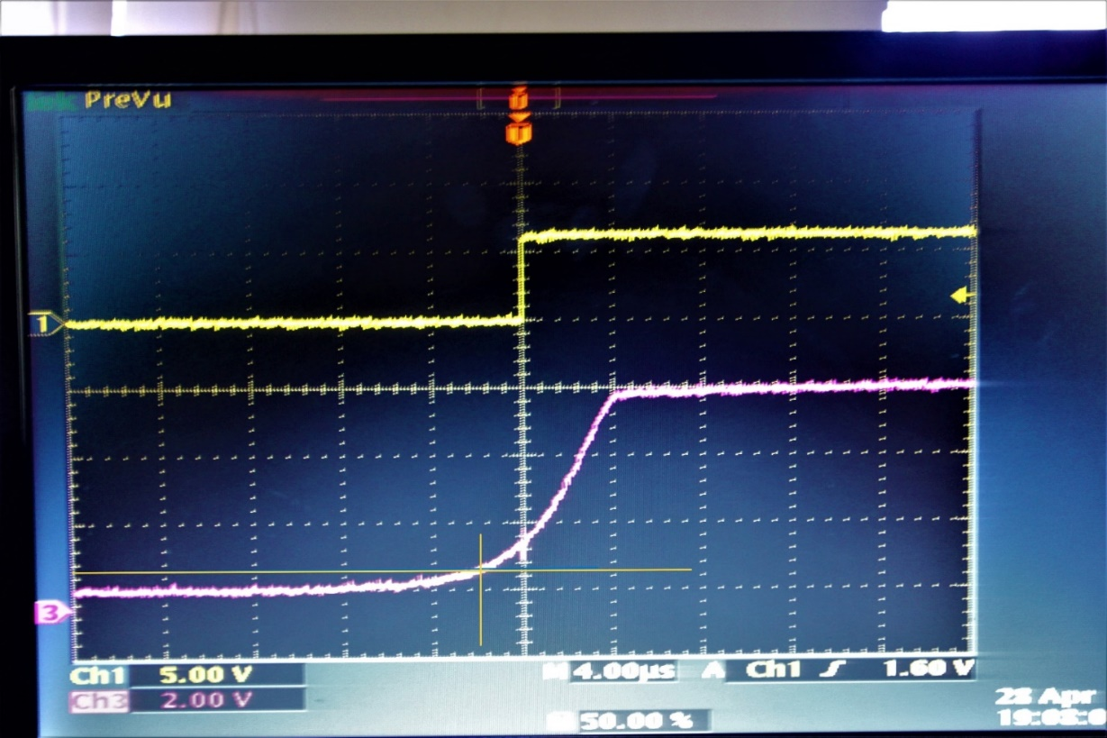

input

output

Input rises gradually to ~6 V after light detection.

Delay is measured from 10% level (0.6 V) to output transition.

Estimated delay ≈ 2 µs.

**Comparison with standard Flash Detectors available at PXE:**

Experimental Setup:

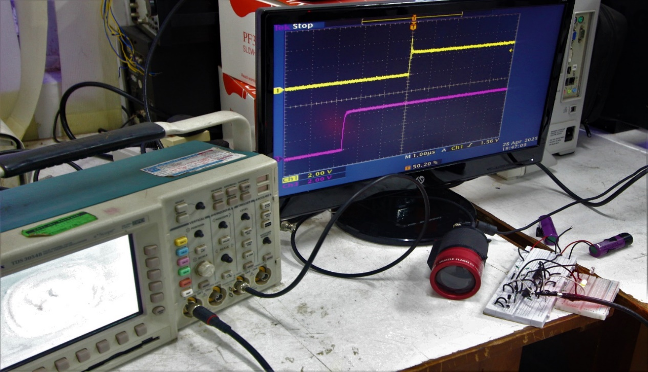

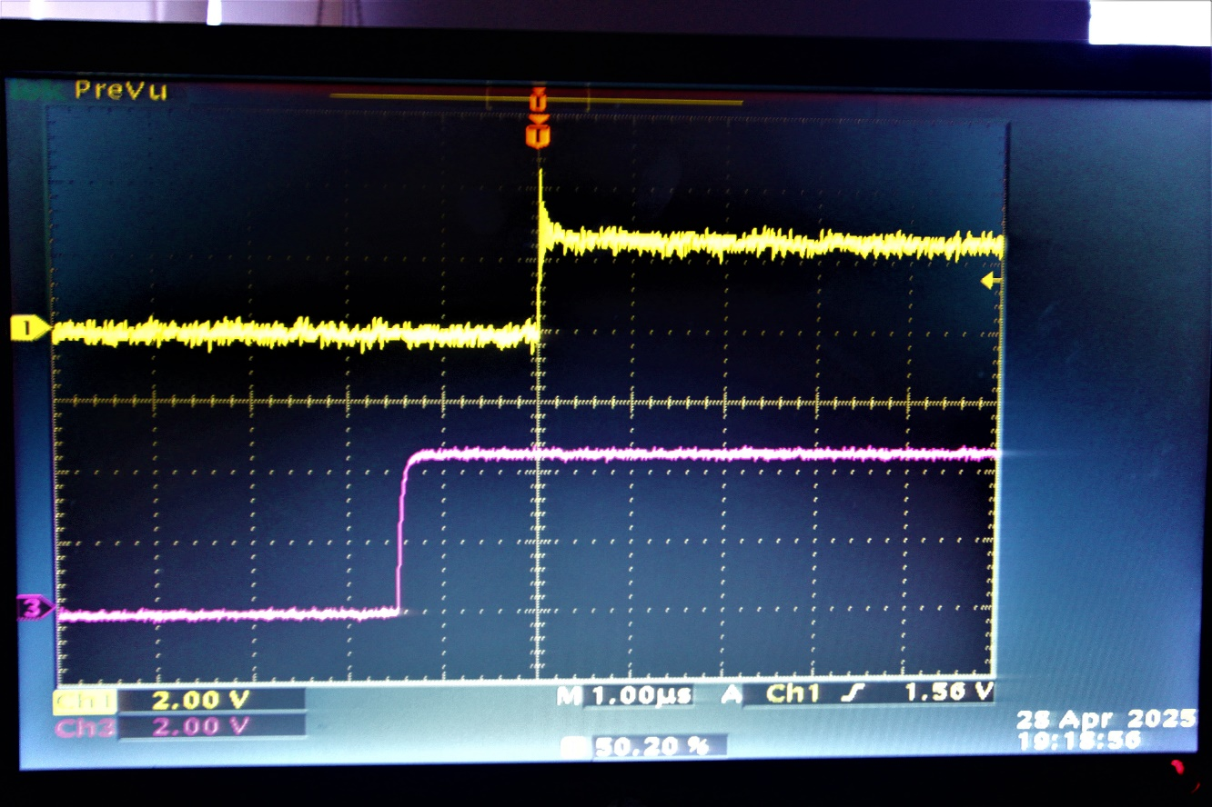Result:

Delay between the standard Flash Detector & the implemented design = 1.5 µs

**Comparison with standard Flash Detector-2 :**

Experimental Setup:

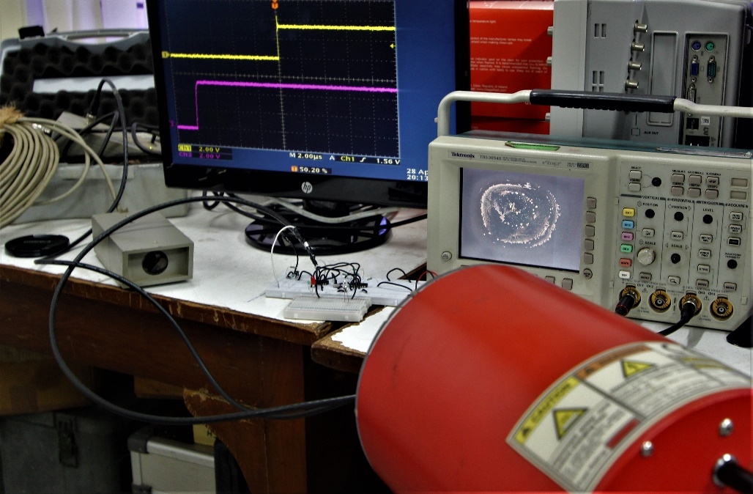

Result:

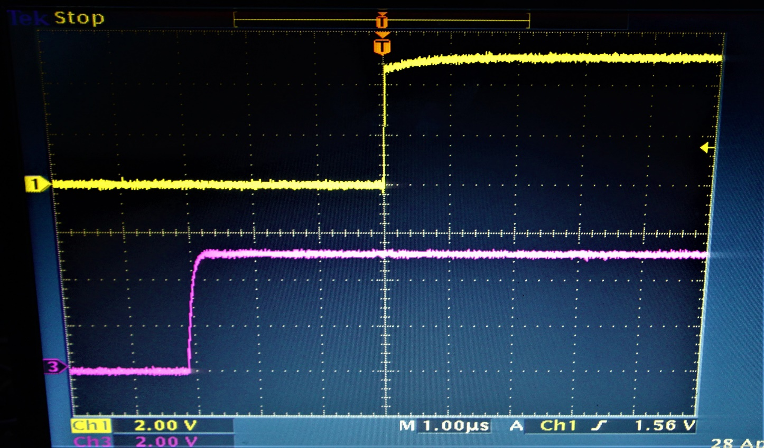

Delay between the standard Flash Detector & the implemented design = 3 µs

(no light condition)

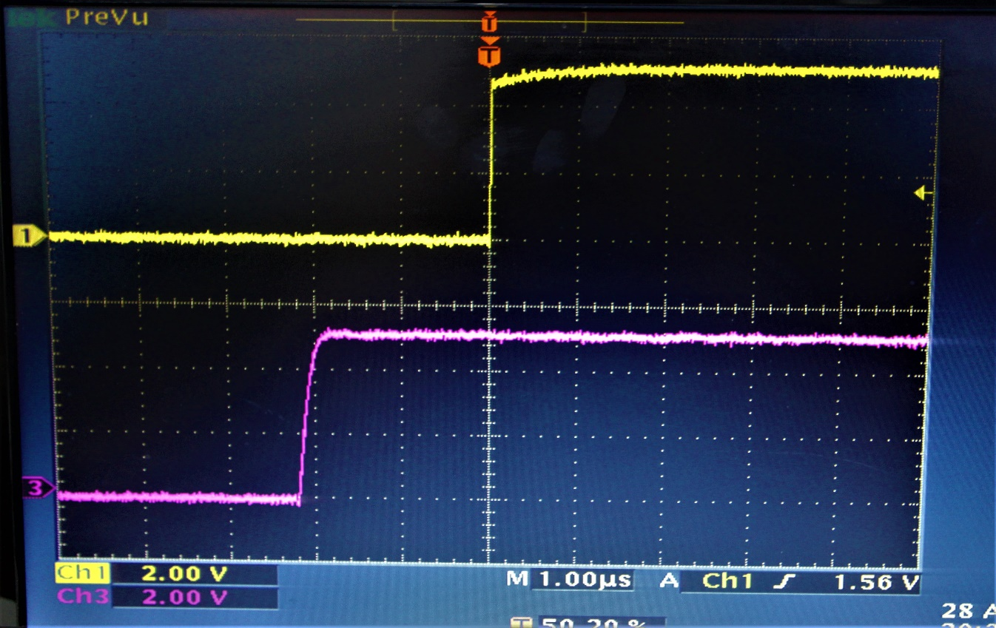

Delay between the standard Flash Detector & the implemented design = 2.2 µs

(ambient light condition)

**Triggering Fastcam SA5 using the implemented design:**

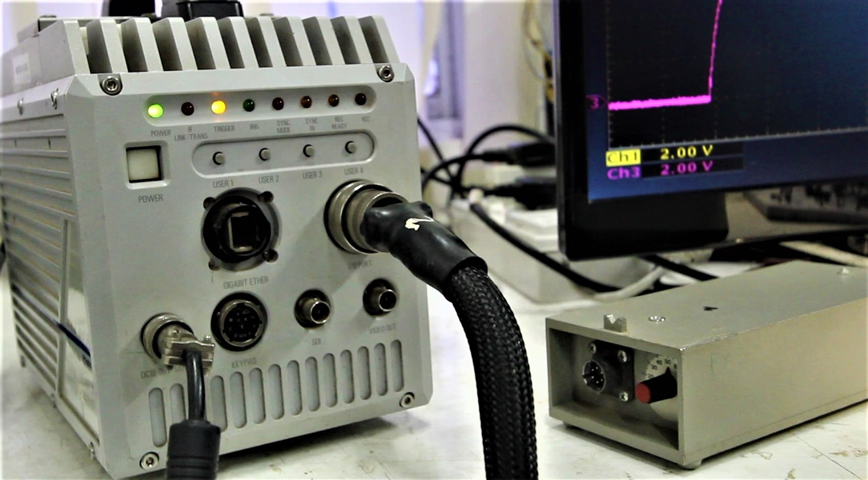

The o/p voltage of the practical circuit is 5 volts which is sufficient enough to trigger the High-speed camera.**Advanced Design: Theoretical Maximum Performance Flash Triggering Circuit**

**Objective**

To explore the fastest possible implementation of a flash triggering circuit using state-of-the-art components, this section outlines an ultra-fast design capable of achieving nanosecond-level response times. The aim is to push the boundaries of temporal resolution for applications requiring precise optical event triggering, such as ballistic experiments, high-speed photography, or plasma discharge studies.

**Component-Level Upgrade Summary**

To achieve sub-nanosecond response, each component of the original design was replaced with its highest-performance commercially available alternative. The table below summarizes the original components, their advanced counterparts, key specifications, and procurement sources:

|  |  |  |  |
| --- | --- | --- | --- |
| Original Component | Advanced Replacement | Key Parameters | Source |
| BPW34 Photodiode | Hamamatsu G11193 SiPD | 0.5 ns rise time, 15 pF (at 12V) | Digi-Key #1480-1032-ND |
| BC547 BJT | MACOM MA4-1315 GaAs HBT | 25 GHz bandwidth, 0.1 ns switching | Mouser #894-MA4-1315-TR1 |
| 74HC04 Inverter | Hittite HIMC86 GaAs Inverter | 0.05 ns delay, 5V compatible | ATOW Electronics |
| 74HC74 D Flip-Flop | Renesas HMC7043 GaAs DFF | 0.25 ns clock-to-Q delay | Renesas Direct |

**Signal Flow and Cumulative Delay Calculation**

The proposed ultra-high-speed circuit follows the architecture below:

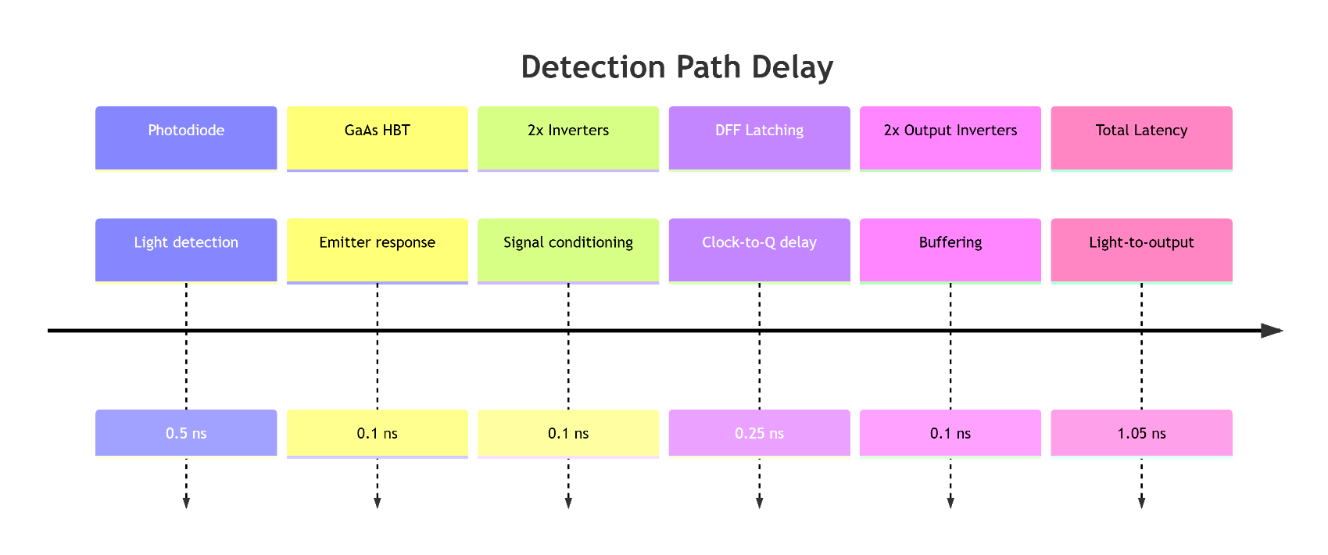

**Performance Comparison: Original vs. Advanced Design**

|  |  |  |  |
| --- | --- | --- | --- |
| Metric | Original Design | Advanced Design | Improvement |
| Latency | ~2 seconds (due to LDR) | 1.05 ns | ~**1.9 million×** |
| Max Trigger Rate | 10 kHz | 500 MHz | **50,000×** |
| Optical Sensitivity | 100 µW | 5 nW | **20,000×** |

The advanced design not only improves speed but significantly boosts sensitivity, enabling detection of much weaker optical events.

**Practical Constraints and Feasibility**

Despite the impressive theoretical performance, the implementation of this design poses several real-world challenges in terms of component cost, availability, and fabrication requirements.

**1. Component Cost and Lead Time**

|  |  |  |  |
| --- | --- | --- | --- |
| Component | Example Part | Unit Price | Lead Time |
| Photodiode | Hamamatsu G11193 | ~$420 | 18 weeks |
| Amplifier | MACOM MA4-1315 | ~$380 | 12 weeks |
| DFF | Renesas HMC7043 | ~$270 | 26 weeks |

These components are often part of military or aerospace supply chains, making them impractical for rapid prototyping or academic labs.

**2. Recommended Practical Alternatives (Cost-Efficient Substitutes)**

A more accessible design can still achieve nanosecond-scale performance using components that cost a fraction of the premium ones, with marginal penalties in speed.

|  |  |  |  |
| --- | --- | --- | --- |
| Function | Practical Alternative | Price | Delay Penalty |
| Photodiode | Thorlabs DET025AFC | ~$85 | 1 ns vs 0.5 ns |
| Amplifier | ON Semiconductor NBSG86 | ~$22 | 0.15 ns vs 0.1 ns |
| D Flip-Flop | TI SN74AXC1G74 | ~$1.20 | 3.5 ns vs 0.25 ns |

**3. Supply Chain and Procurement Limitations**

* **Stock Status:** Many high-speed components like the G11193, MA4-1315, and HMC7043 are marked *"Factory Order Only"* or *"Not in Stock"* at standard distributors (e.g., Digi-Key, Mouser).
* **Distributors:** Often require procurement through RF/military-specialty vendors like Richardson RFPD.
* **Lead Times:** Commonly range from 12 to 26 weeks, even for small quantities.

**4. Fabrication and PCB Constraints**

Implementing a 25+ GHz analog front-end also requires:

* **High-speed PCB Substrate:** Rogers 4350B (~$500 per panel)
* **Advanced Fabrication:** Laser-drilled vias and controlled impedance traces

Such requirements make the design suitable only for **funded research projects or commercial applications** with access to defense-grade PCB services.

**5. Side-by-Side Implementation Comparison**

|  |  |  |
| --- | --- | --- |
| Parameter | Theoretical Max | Practical Alternative |
| Total Cost | ~$1,520 | ~$120 |
| Latency | 1.05 ns | ~3 ns |
| Max Trigger Rate | 500 MHz | 200 MHz |
| Build Time | 6–12 months | 2 weeks |
| Test Equipment | ~$50,000 (GHz scopes, probes) | ~$5,000 (entry-level 1 GHz scope) |

**Conclusion**

The **1.05 ns design** represents the theoretical limit of flash detection using currently available components. However, for most academic and hobbyist applications, a practical alternative design achieving **3 ns latency** and **200 MHz triggering rate** is more than sufficient.

These optimized alternatives strike a balance between **performance**, **cost**, and **availability**, making nanosecond-scale flash detection feasible without resorting to exotic or military-grade hardware.

### **Conclusion**

The DRDO Summer Internship at PXE, Chandipur, was a transformative experience that deepened our technical knowledge and exposed us to real-world defense research. The project focused on three key areas: human reaction time analysis using high-speed imaging, detection and analysis of LED flickering, and the design of flash-triggered camera circuits.

Through the reaction time experiment, we precisely measured the latency between stimulus and response using frame-by-frame analysis at 1000 fps. This highlighted how even milliseconds are critical in defense operations such as live surveillance, UAV control, or missile launches. In the LED flicker analysis, periodic variations in RGB intensity was detected, correlating with 50 Hz AC power fluctuations. These findings stress the importance of using flicker-free lighting in high-speed optical systems to prevent false detections or vision errors.

The final task involved developing two flash-triggering circuits: one using an LDR and the other an IR-based optocoupler. Both designs successfully detected sudden flashes, generating a sharp 5V output pulse for activating high-speed cameras. These circuits improve data accuracy and reduce storage load by ensuring recordings begin only upon actual firing events.

This internship enhanced our skills in embedded systems, signal processing, and defense-grade experimentation, aligning with DRDO’s vision of Atmanirbhar Bharat in defense technology.

**REFERENCES**

[3] - <https://www.drdo.gov.in/drdo/labs-and-establishments/proof-experimental-establishment-pxe>

[4]-<https://www.drdo.gov.in/drdo/labs-establishment/historical-background/proof-experimental-establishment-pxe>

<https://en.m.wikipedia.org/wiki/Proof_and_Experimental_Establishment>

[5]-<https://www.drdo.gov.in/labs-establishment/combat-vehicles-research-development-establishment-cvrde>

[6] - <https://www.drdo.gov.in/labs-and-establishments/armament-research-development-establishment-arde>

[7] - <https://www.drdo.gov.in/technology-cluster/armaments-and-combat-engineering/arde>

[16] - <https://pmc.ncbi.nlm.nih.gov/articles/PMC4456887/>

[20] - <https://www.researchgate.net/figure/R-LED-flash-detection-circuit_fig6_228506348>